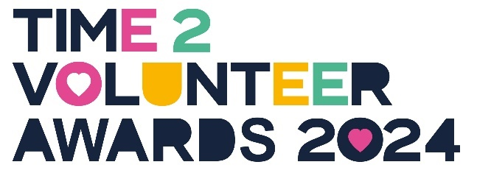

Time2Volunteer Awards 2024 Nomination Form
Proudly brought to you by HEY Smile Foundation and partners, Hull CVS, East Riding of Yorkshire Council and Hull City Council and MADL.
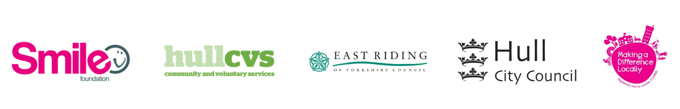

Volunteers in our community do the most amazing things! We want to recognise these inspiring people for the fantastic work they do, by celebrating the power of volunteering.
Please nominate people from Hull, East Yorkshire and North & North East Lincolnshire who have volunteered in the last 1 months, since May 2023 (unless it’s for the Founding Volunteer or Long-Serving Volunteer categories).
Your nomination will be judged on the quality in terms of volunteer impact only, not on the number of nominations received for the same person. Please sit back with a cuppa, include as much information as possible, and tell us about an amazing volunteer you know!
It’s free to nominate and all shortlisted nominees will receive two complimentary tickets to an Awards ceremony and celebration at the DoubleTree by Hilton, Hull on Thursday 3rd October 2024, 13:00 – 16:30. Extra tickets can be purchased at £20 per person.
Nominations are open from 1 June – 14 July 2024.

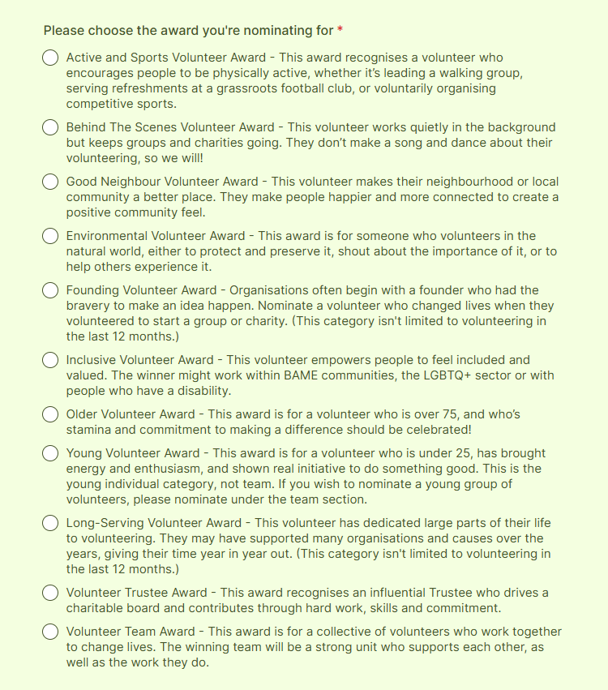

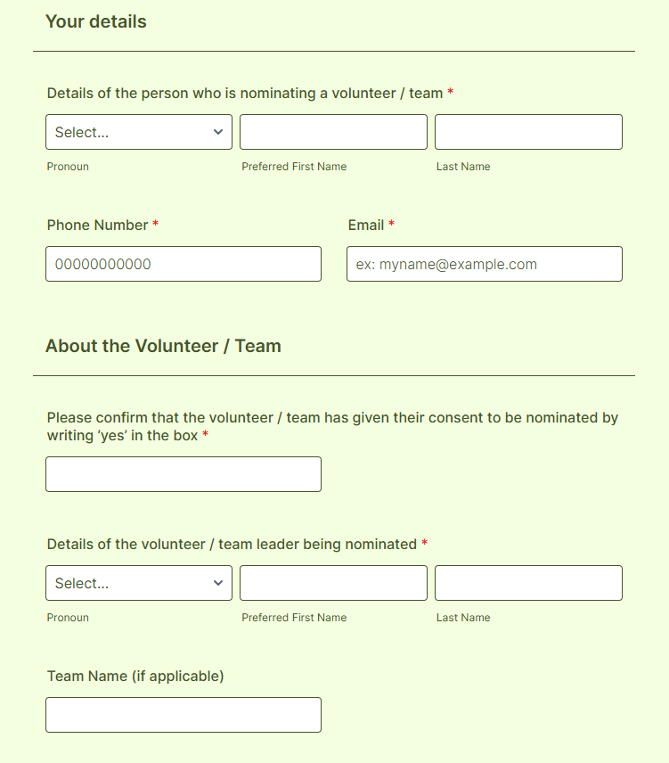

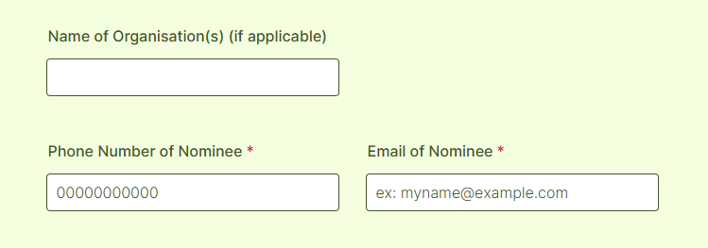

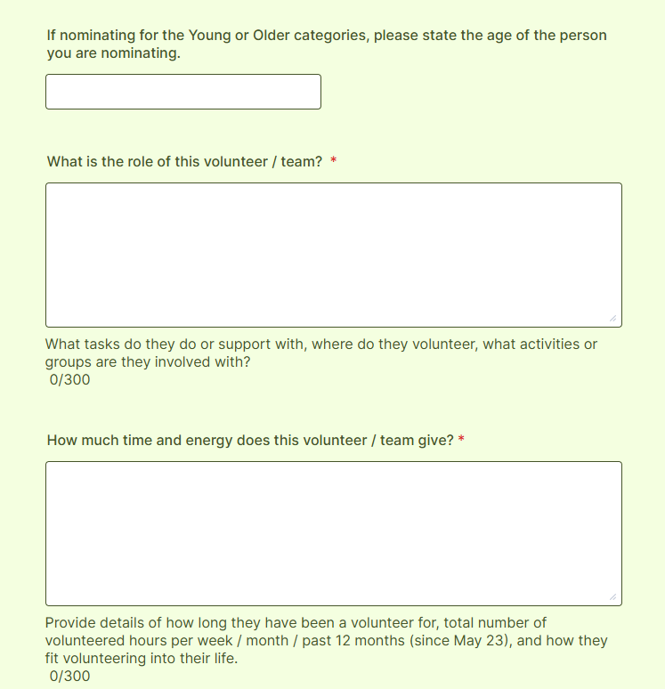
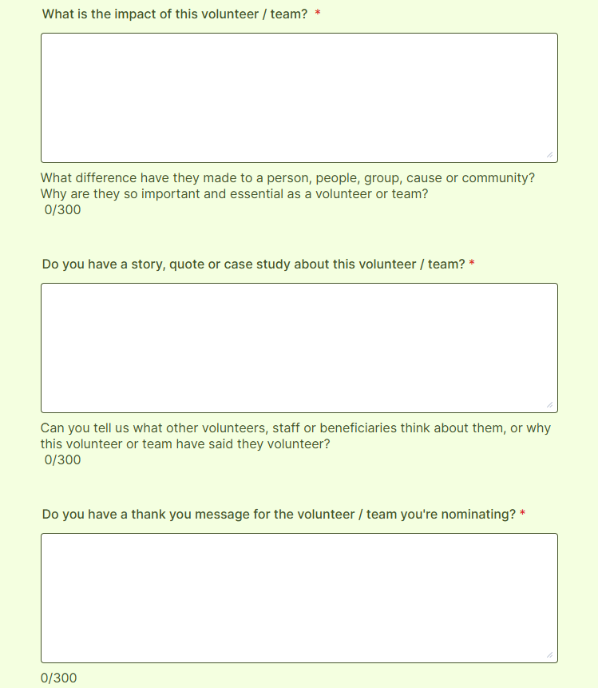
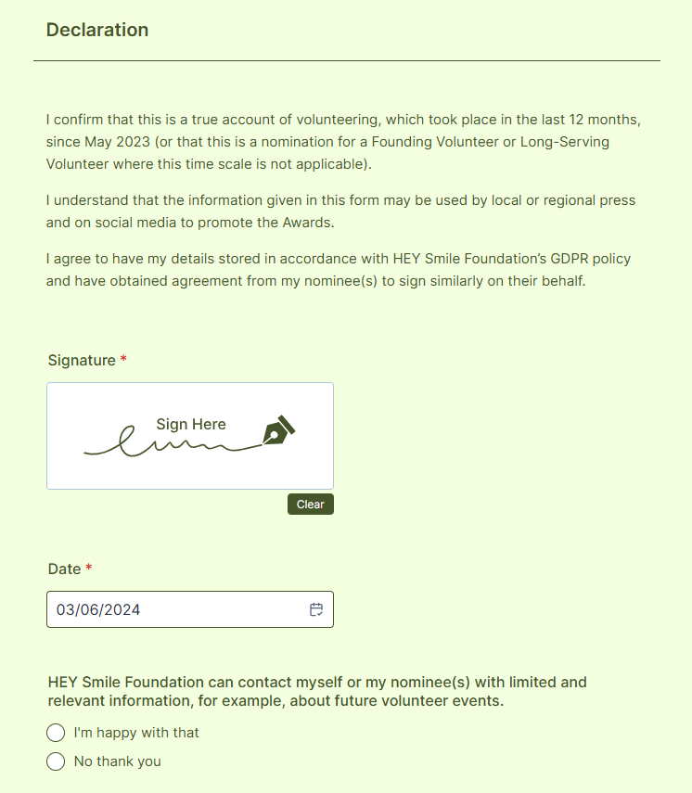

Please return this nomination form to the address below.
HEY Smile Foundation
c/o Gosschalks
61 Dock Street
Queens Gardens
Hull
HU1 3AE

