East Riding 4 Community – saved searches and weekly email Alerts
Search East Riding 4 Community on your web browser.
Register or log in to your account. | 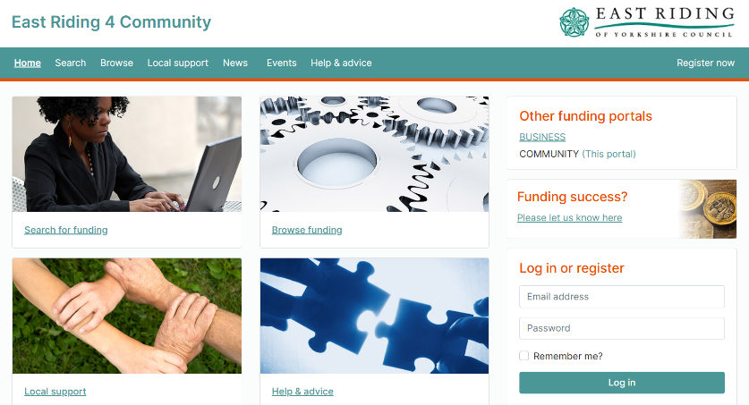
Once logged in, click on ‘Search for funding’.
Type a key word into the search bar. Filter your results further (e.g. type of organisation, area of work, eligible expenditure).
Click on ‘save search’ then ‘add new search’.
Give your search a name, click save.

