15th April 2026
Dear Colleague,
We are writing to invite organisations from the Voluntary, Community and Social Enterprise (VCSE) sector to attend an Engagement Event regarding a commission from HEY Smile Foundation of a Community-Led Prevention Service designed to support adults seeking, waiting for, or at risk of requiring, Adult Social Care intervention.
This is an exciting opportunity to contribute to the development of new ways of working and influence how services will be designed and delivered in the future.
This event forms part of a pre-commission process and gives an opportunity for organisations to learn more about the proposal, ask questions and provide feedback to help inform the programme design. Organisations will be invited to make expressions of interest to join the new initiative.

About the Proposal
The Local Authority is developing a prevention model that will strengthen early intervention and reduce pressure on Adult Social Care waiting lists. We know that the VCSE sector has an important role to play in these developments. The sector has the knowledge and the trust of local communities and harnessing this resource is critical.
As part of the developments Smile Foundation will be the single infrastructure organisation acting as the lead agency, responsible for commissioning and coordinating neighbourhood delivery through a network of local VCSE organisations.
Smile Foundation will provide:
- Commissioning and contract management of community delivery partners
- Safeguarding frameworks, supervision and quality assurance
- Coordination with Adult Social Care and system partners
- Centralised data collection, impact reporting and learning
- Oversight of delivery across multiple localities
Community organisations will provide strengths-based, non-statutory support, helping adults to access community resources, build resilience and prevent escalation of need.
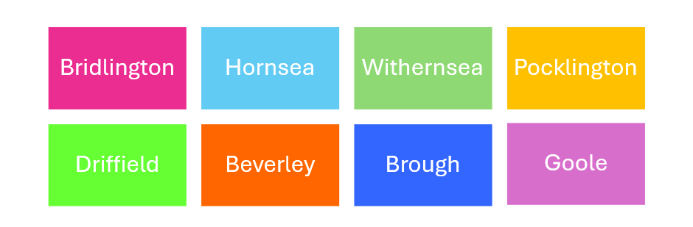
We’re interested in hearing from VCSE community providers located and delivering in the following areas:

We are keen to meet with you if you are:
- A community organisation interested in becoming local delivery partner
- An organisation with experience in helping people and navigating community resources.
If you think your organisation can help we’d like to hear from you.

Purpose of the Engagement Event
The session will:
- Present strategic objectives and a draft service model
- Outline the commissioning approach
- Provide early visibility of a draft service specification and expectations
- Invite feedback and participation from VCSE organisations in the development of the service
- Give opportunity for potential partners to ask questions and share insights
Your participation will help ensure the final service design is deliverable, proportionate and reflective of the strengths of the local VCSE sector.

Event Details
Date: 21st April 2026
Time: 10 am – 12 pm
Location: The Café at the Armstrong Centre, Beverley. HU17 0ED
Duration: 2 hours

How to Register
If you would like to attend, please confirm your attendance by contacting:
Community Team – HEY Smile Foundation
hello@heysmilefoundation.org
Please include the names and roles of any colleagues who will be attending.

Important Information
Participation in this event does not constitute a commitment to commission and attendance will not confer any advantage in any future commissioning process. The purpose of the event is to support open engagement and inform the development of the commissioning approach.
This is an exciting development for our communities, and we are looking forward to engaging with our colleagues in the VCSE sector and working together to strengthen prevention and community-based support for our residents.
Kind regards

