Bridlington Heritage Open Days 2025
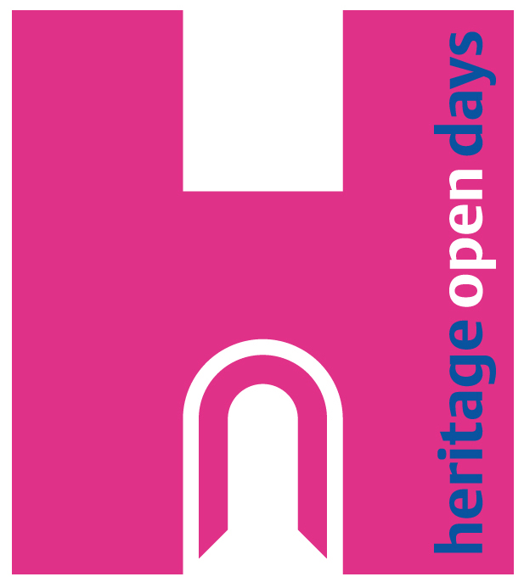

12th of September – 21st September
All events are FREE, please scan the QR Code for each event for full details and Booking information if required.

