Step 1 – Write Your Charitable Purposes (Objectives)
- What? – Your organisations purposes (aims) must be completely charitable.
- Who? – Your charity must benefit a significant section of the public, (or animals) also known as public benefit.
- Where? – Think about the geographical area (a town/county/region)
- How? - What the charity will do to tackle problem of what. Be clear but not too restrictive.
Choose a charity name.
Step 2 – Decide Your Charity Structure
Will your charity be governed by trustees only or a wider membership?
- A charity governed entirely by its trustees – only constitutional members can make crucial decisions.
- Wider membership – Trustees are accountable to those members. Some decisions can only be made by a wider membership such as electing trustees, approving annual accounts and changes to constitution.
The charity has a duty to keep records of all members. Members are invited to annual general meetings where they can elect trustees, approve accounts, and ask how the trustees have been managing. A charity with members is often called an association or society.
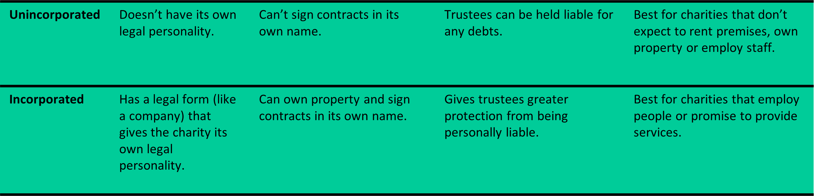
Step 3: Choose the Governing Document That’s Right for You
A governing document is a set of rules on how your charity is run. It includes matters such as purposes, number of trustees and how they are appointed, how to give notice of meetings and how to close the charity. Use the Charity Commissions own models.
Step 4: Recruit Your Trustees
Trustees must always act in the charity’s best interests, manage resources responsibly and ensure the charity is carrying out its purpose. Trustees are usually unpaid unless special permission is given by the charity commission. They sometimes have a set term of office and meet between 4 – 12 times per year to discuss charity business. You should choose trustees who, together, can provide the skills and experience most needed to oversee the work of your charity. You will need a chair and a treasurer. At least 3 unrelated trustees are needed to register with the Charity Commission.

Step 5 – Money matters
Opening a charity bank account is not a requirement but for most structures, the Charity Commission will require proof of income as part of the registration process – often proved using a bank statement. Set up an account that requires two signatures to release expenditure.
Keep documentation to show the source of your income and how it was spent.
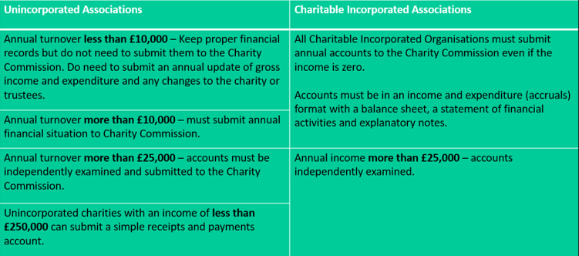
Step 6 – Apply for Registration
First register with the Charity Commission, then you will be able to access the online application form.
You will need:
- The name of the charity
- Bank or building society details (if required)
- Most recent accounts
- Names, dates of birth and contact details of trustees
- Proof of income (e.g., a recent bank statement as a scanned image)
A declaration of responsibility and eligibility form (signed by trustees) and governing document will also need to be submitted.
Expect a response in up to 45 days.

