

Being kind to ourselves: Compassion Focused Therapy for mood in dementia

You are not alone.
Many people living with dementia also have low mood or difficult feelings.
We are working with University College London on a research study and invite people living with dementia to try a 12-week group called Compassion Focused Therapy.

We are taking part in a research project with University College London.
Would you be interested in joining?
We would like to invite people living with dementia to try out a 12-week online group intervention (Compassion Focused Therapy) to help people living with dementia and low mood.

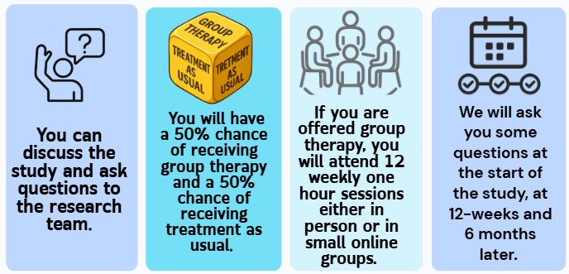
If you are interested in hearing more, please talk to a member of staff or contact - hnf-tr.researchteam@nhs.net
What will happen if you take part?

It’s a talking therapy that helps people feel supported, understood, and kinder to themselves.

If you are interested in hearing more, please talk to a member of staff or contact Mel Melville melissa.melville@nelft.nhs.uk 07305269604

