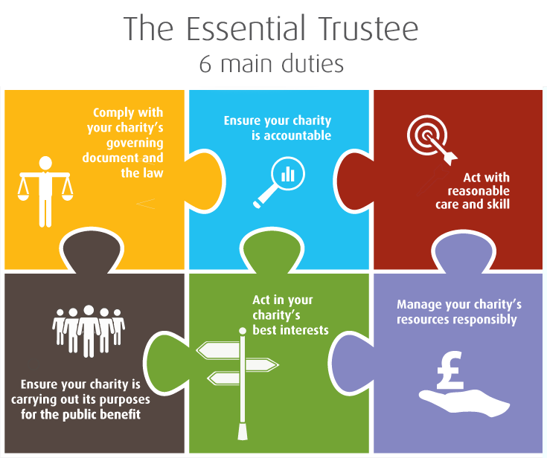

Comply With Your Charity’s Governing Document and The Law
Every trustee should have a current copy of their charity’s governing document and refer to it regularly. To ensure it meets the charity’s present needs, review it from time to time.
Register with Charity Commission unless you:
- are an exempt charity.
- have an annual income below £5,000.
- are not a Charitable Incorporated Organisation (CIO)
All registered charities:
- inform the Charity Commission of any changes to your information on the charity register.
- must send an annual return/update to the Charity Commission
- must comply with additional accounting and reporting requirements.
Some laws, such as equality and data protection, apply to all charities.
Trustees should keep up to date with legal and regulatory requirements which could be found by receiving mailings from the Charity Commission, reading relevant guidance, and attending training.
Ensure Your Charity Is Accountable
Trustees always remain collectively responsible for all decisions and actions that are made with their authority.
All charities must produce accounts and provide a copy of the most recent to anyone who asks. The accounts your charity must produce depends on whether it is a company and how much income it receives.
Take account of what your members, beneficiaries and funder say and use this information to inform decisions and improve the charity’s services.
Have clear channels of communication and ensure procedures are followed. People involved in your charity (staff, volunteers, other trustees) are held to account for how they carry out their role or use the charities resources. Ask probing questions when necessary.
Act With Reasonable Care and Skill
Use your skills and experience to inform decision making to benefit your charity.
If something does go wrong, act promptly, and take appropriate action. Take reasonable steps to prevent it from happening again like reviewing procedures and acknowledging advice.
The Charity Commission requires charities to report serious incidents, loss of your charity’s money or assets, damage to your charity’s property.
Ensure Your Charity Is Carrying Out Its Purposes for The Public Benefit
Public benefit is essential to charitable status.
Ensure you understand the charity’s purposes set out in its governing document and decide with fellow trustees what activities the charity will undertake and the resources it will need to fulfil these aims. Occasionally review the charity’s object to make sure they are still relevant. Charities can modify their objects if necessary.
Act In Your Charity’s Best Interests
Together, the trustees should make balanced and informed decisions, considering the short term and long term outcomes. You should record how you made more significant decisions in case you need to review or explain them at some point.
A conflict of interest is any situation where your personal interests could prevent you from making a decision in the charity’s best interests. You must follow and specific conflict of interest specifications in your governing document. If a trustee (or a person connected to a trustee) stands to benefit from a decision, the conflicted trustee(s) should remove themselves from the decision making process and connected discussions.
The Charity Commission can only advise or intervene in relation to trustees’ legal duties – it can’t mediate disputes between trustees.
Manage Your Charities Resources Responsibly
Make sure the charity’s assets are only used to support or carry out its purposes.
All charities should have suitable financial controls meaning more than one person is involved in receiving income and authorising expenditure. A charity can only succeed if it manages its money and other resources properly. You need to monitor income and expenditure, keeping accurate records, so the charity can meet its goals. It’s best to avoid relying on a single source of income. You should have an appropriate reserves policy.
A risk is anything that could affect your charity achieving its purposes and carrying out its plans. Risk management is the process of identifying and assessing risks and how to deal with them – this includes safeguarding risks.
Trustees have responsibility towards any volunteers or staff. Ensure that people are clear about what they are supposed to do though role descriptions, and that people know what to do if there’s a problem. You should make sure volunteers and staff get appropriate training and they comply with policies and procedures. The charity must comply with relevant law including employment, pension, equality and health and safety.

