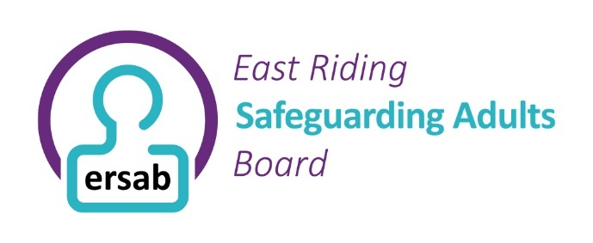
Safeguarding Adults Board – Lay Member Role Description
About the Role
We are looking for people from the local community to join the Safeguarding Adults Board as a Lay Member.
A Lay Member is someone who is not representing a professional organisation but brings an independent voice and community perspective to the Boards work. The lay member may also have a lived experience.
You do not need previous safeguarding experience. We are looking for people who care about the wellbeing, safety, and rights of adults in our communities.
Purpose of the Role
As a Lay Member, you will help the Board understand the experiences of local people. You will ensure that the views of residents, people who use services, carers, families, and communities are considered when decisions are made.
You will provide constructive challenge, ask questions, and help the Board remain focused on what matters most to people.
Main Responsibilities
As a Lay Member, you will:
- Attend Board meetings and contribute to discussions.
- Share the perspective of local communities and residents.
- Help ensure people with lived experience are heard and considered.
- Ask questions and offer independent views.
- Support the Board's commitment to openness, inclusion, and continuous improvement.
- Review information provided before meetings where possible.
- Respect confidentiality and act in accordance with the Board's values.

What We Are Looking For
We are looking for someone who:
- Has an interest in improving the lives of adults in the community.
- Can listen to different viewpoints and express their own views respectfully.
- Is willing to learn about safeguarding adults.
- Can think independently and ask questions.
- Is committed to equality, diversity, and inclusion.
- Can maintain confidentiality where required.

Time Commitment
The Board currently meets 6 times each year. There may also be occasional development sessions, training opportunities, or workshops.
Support Available
Training, induction, and ongoing support will be provided. Reasonable adjustments will be made to ensure that everyone can participate fully.
What You Can Bring
Your life experience, knowledge of your community, and independent perspective are valuable. We welcome applications from people of all backgrounds and are particularly keen to hear from people whose voices are not always represented in public decision-making.
Together, we can help ensure that adults in our communities are safe, respected, and supported to live the lives they choose.
What we can offer
£15 per hour plus any travel expenses (upon receipt of travel ticket).
What to do if you are interested
If you are interested in taking up this opportunity please send an email to ersab@eastriding.gov.uk outlining why you are interested and what you think you can offer to the partnership. The deadline for this is Friday 21st August 2026.
A short discussion/presentation will be held at a suitable time and date with you to help us make a decision.

